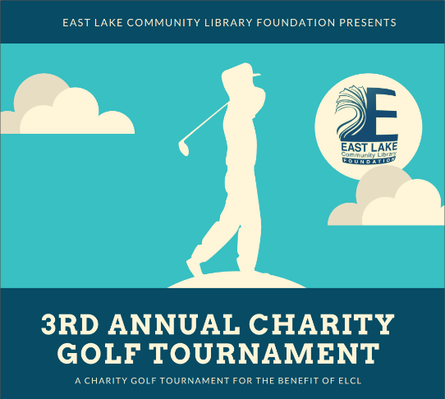
SPONSORSHIP OPPORTUNITIES
Support the East Lake Community Library Foundation’s funding of capital projects and future expansion while promoting your company through numerous tournament sponsorship options. Don't miss this opportunity to market your products and services to our tournament participants!

Some opportunities for sponsorship are outlined below, but feel free to create your own. No donation is too small to make an impact.
FEATURED SPONSOR - $2,500
Two foursomes; Name/logo on all e-mails and letters sent;
two hole signs; recognition at banquet;
2x4 banner for display.
1 available

2 available
TOURNAMENT SPONSOR - $1,500  Name/logo on website, signs at event, e-mails; two hole-sponsor signs; one foursome;  Recognition at banquet.  2 available | VOLUNTEERS SPONSOR - $1,000  Name/logo on website and all volunteer golf shirts; Recognition at awards banquet  and dinner for two.  1 available
LUNCH SPONSOR - $1,000  Name/logo on website and in program;  one hole sign and  dinner for two.  1 available | DINNER SPONSOR - $1,000  Name/logo on website and in program;  one hole sign and  dinner for two.  1 available
HOLE IN ONE INSURANCE - $500  Name/logo on rules sheet;  Signage on course (two par 3’s).  1 available | DRIVING RANGE - $350  Name/logo on rules sheet;  Signage on driving range.  1 available
PUTTING CONTEST - $300  Name/logo on rules sheet;  Signage on putting green.  1 available | SPECIAL HOLES CONTESTS - $250  (closest to the pin, longest drive, etc.)  Signage on tee box.  4 available
HOLE SPONSORS - $150  Signage on tee box.  6 available | IN-KIND DONATIONS**  (Goodie bags, silent auction items, etc.)  Please indicate on back.  Unlimited
ALL SPONSORS WILL BE LISTED IN THE PROGRAM GUIDE AND ON OUR WEBSITE THROUGH 2020

** Additional Donation Opportunities include:
- Imprinted Goodie Bags for 100 golfers
- Items for Goodie Bags - gift certificates, coupons, promotional items for 100 bags
- Snacks, candy, bottled water (100)
- Live/Silent Auction items or baskets (minimum value: $100)
- Entry fees for a foursome of employees, friends, etc.
Any unique way to showcase your business will be considered.
SPONSORSHIP FORM

NAME ____________________________________________________________________________

COMPANY ____________________________________________________________________________

ADDRESS ____________________________________________________________________________

____________________________________________________________________________

PHONE ____________________________________________________________________________

E-MAIL ____________________________________________________________________________

SPONSORSHIP LEVEL _____________________________ CHK # _____________________________

IN-KIND DONATION** ____________________________________________________________________

DONATION VALUE _______________________

**IN-KIND DONATIONS MUST BE DELIVERED TO EAST LAKE COMMUNITY LIBRARY BY 4/18/2020
(or make arrangements for pickup through the Library Director, Lois Eannel, @ 727-773-2665 x203)
Please indicate how you would like your sponsor sign to read:

Please mail your tax-deductible checks payable to:

East Lake Community Library Foundation
4125 East Lake Road, Palm Harbor, FL 34685

For questions or further information, please contact Dan Wendol at info@elclfoundation.org

Thank you for your support!

